# How to use the multipage Picture it template

Technical note: The multipage Picture it template uses a css style sheet that lives in the director /docs/common_css. If you update the css, the updates must be copied to the prod bucket in S3 before the updates will appear on prod. Any update made to the css will affect all the multipage Picture its.  
  
--

Before you begin, upload the images you plan to use for each page of the multipage Picture it to the ancillary files table in CAMPER. The images should go in the same directory as the main multipage Picture it. You need to include the image file extensions in their CAMPER file name.

After the images are uploaded, do the following:

1. Download the latest version of the multipage template from the directory that this document lives in.
2. Open in Brackets or some other html editing program
3. If your Picture it will live in a mini-lesson directory instead of a module directory, adjust the css directory reference in the “head” section to start with ../../ instead of just ../

How it should look for a mini-lesson directory:



How it should look for a module directory:



4. Update the title: 

5. Add or remove sections as needed for the number of pages you plan to have. If you are adding sections, copy one of the middle sections and paste it to add the additional sections you need. Note that the button areas for the first page and the last page are different from the button area for the middle pages, so it is easiest to leave the first and last page sections intact. A page section looks like this:

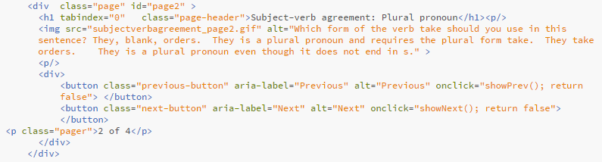

6. For each page, update the following:

1. Page header--this is the h1
2. Image source. Assuming the image is in the same directory as the multipage Picture it, this can be the image file name, including the extension.
3. Alt text for the image, used for screenreaders
4. Pager--update the total number of pages and the current page number for each page as needed.

7. Upload the multipage file using the CAMPER ancillary files table, and put it in the same directory as your images.